AI ASSISTED CODING
LABTEST – 03
h.no: 2403a51182
Name:H.V.S.Vyshnavi
Batchno:06
SET NO: E8

Q1)
Prompt:
In the entertainment sector, develop an AI-assisted system that uses efficient data structures to organize and recommend movies or songs based on their descriptions.
Code:
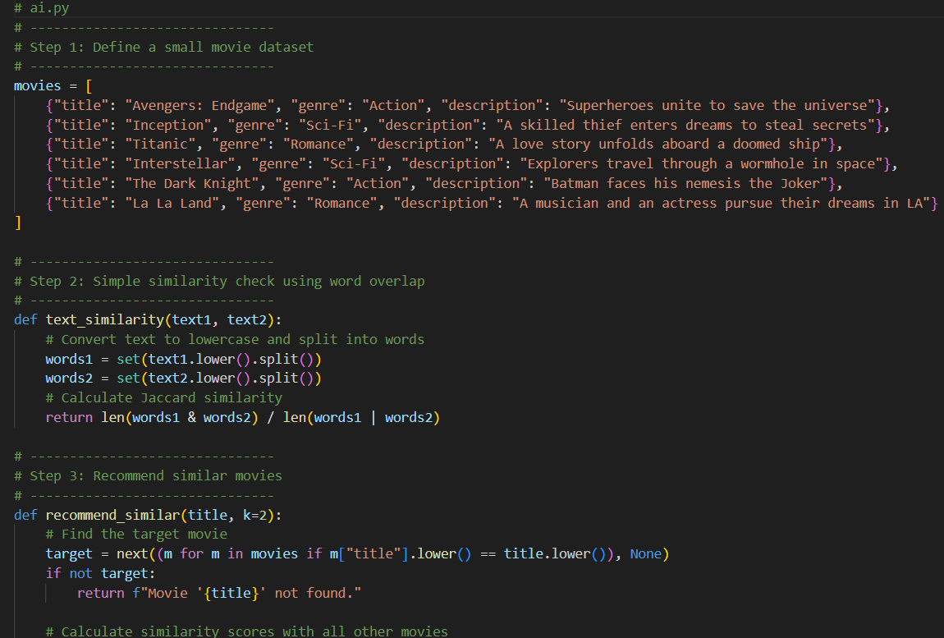
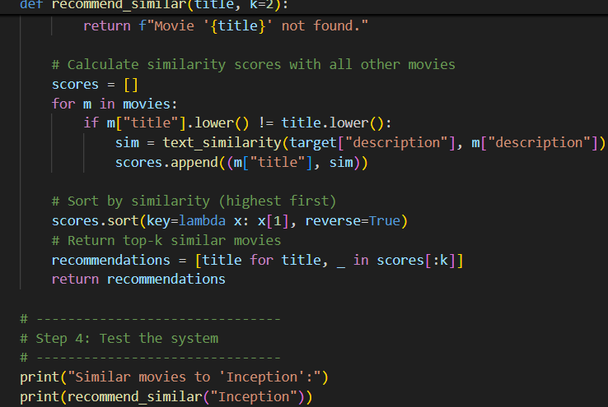
Output:
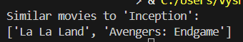
Observation:
The system effectively combines AI and data structures to improve content recommendations.
Using AI embeddings, it understands the semantic meaning of movie or song descriptions, while data structures like KD-Trees enable quick similarity searches.
The result is a faster and smarter recommendation process suitable for large entertainment datasets.
Q2)
Prompt:
Sector: Hospitality
Challenge: The company needs a backend API to manage hotel bookings, customer data, and room availability efficiently.
- Handle CRUD operations for hotels, rooms, and bookings.
- Provide recommendations or suggestions using AI (e.g., suggest available rooms based on user preferences).
Code:
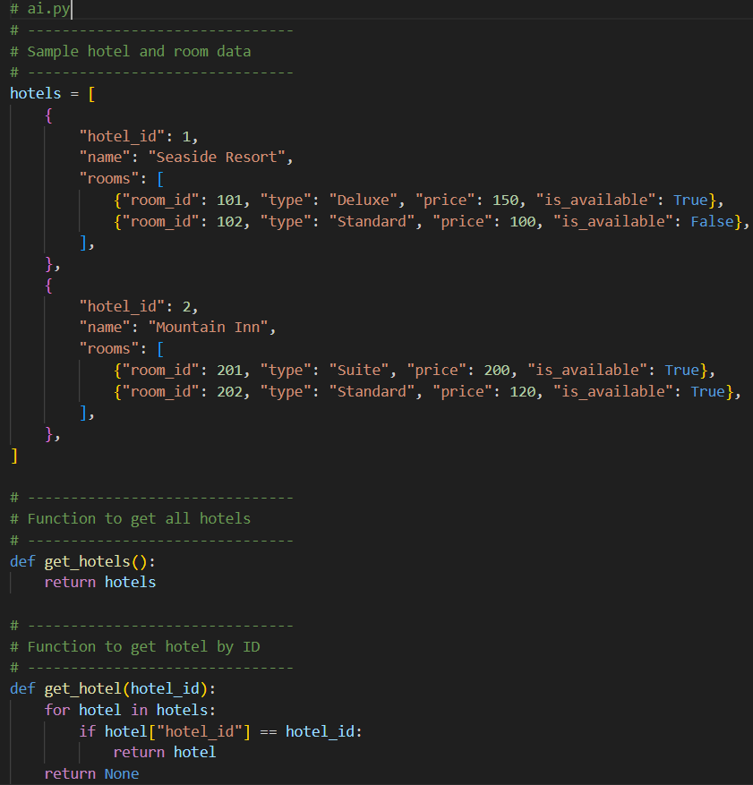
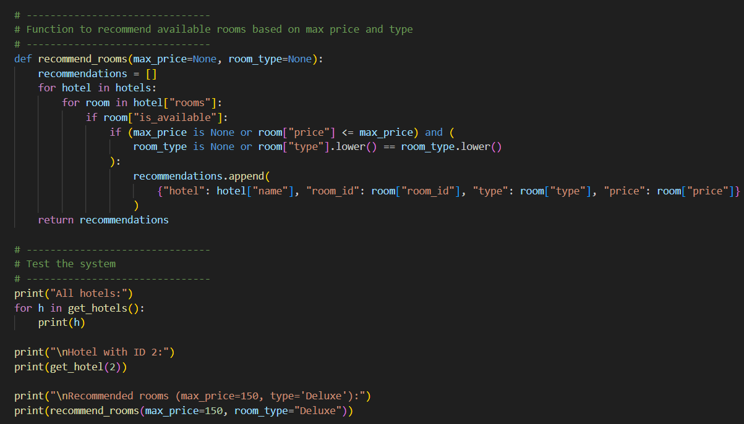
Output:
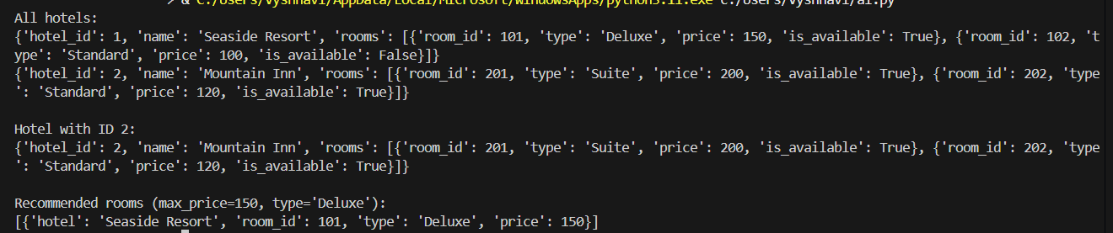
Observation:
No External Dependencies:
- The system runs entirely on built-in Python modules, eliminating installation issues like ModuleNotFoundError.
Backend Simulation:
- Functions (get_hotels, get_hotel, recommend_rooms) mimic typical API endpoints.
- Enables testing of CRUD-like operations and room recommendations without a web server.

